Working with Subject Librarians to Make Difficult Preservation Decisions
By Barbara Hatcher and Kara M. McClurken
Abstract: Preservation Services at the University of Virginia (U.Va.) Library has experienced a period of growth in staff and expansion of services over the last five years. One new program, designed to ensure that staff are spending their time and resources on the materials that the users most need, is the new Severely Damaged Workflow. Preservation Services developed a new position, Subject Librarian Liaison, to collaborate with the Subject Librarians on difficult preservation decisions, allowing us to efficiently process several hundred heavily damaged books per year and focus our resources on the materials that are of highest value to our researchers.
Every library has one—a sad shelf (or set of shelves) filled with severely damaged library materials. Some are filled with books made from brittle, decomposing paper; others contain victims of dog chewing or windows left down during rain storms. Some hold cracked CDs, or microfilm that smells suspiciously like vinegar. But who has the time to deal with these poor, broken objects? A heavily checked-out and worn volume from the Harry Potter series requires little decision-making on the part of Preservation Services—such volumes are easily rebound or replaced, but what about those items that are not so easy to repair or replace? Sometimes, those responsible for the care of the collections need a little bit of help when making such decisions. At the University of Virginia Library, we turn to Subject Librarians, whose subject expertise can help us decide the best preservation decisions for these items.

Subject Librarians at the University of Virginia Library carry out a variety of responsibilities outside their collection development duties, including teaching and library instruction, working at the reference and circulation desks, and participating in online reference chat consultations. Unfortunately, this leaves little time to deal with the brittle, broken, or badly damaged books and materials that stack up on “Decision needed” shelves in all twelve branches of our libraries across grounds. At the very least, these items often fall to the bottom of the priority list. By collaborating with our Subject Librarian colleagues and developing a well-organized workflow that minimizes the time spent gathering data and making decisions, Preservation Services has efficiently dealt with several hundred critical condition books within the first year of this program’s implementation.

BACKGROUND
The University of Virginia Library consists of twelve libraries, with independent libraries for health sciences, law, and business. The U.Va. Library supports 12,000 undergraduates, 6,000 graduate students, and 1,600 teaching faculty. The Library has served as a central focal point of the grounds since the University’s founding in 1819. Originally located in the Rotunda--based on the Roman Parthenon--the library collection was at the center of Thomas Jefferson’s Academical Village. Jefferson placed the books “in the Rotunda’s upper floor beneath the soaring dome and so converted the temple of the pagan gods into a temple of enlightenment.” A fire in 1895 damaged the majority of the U.Va. Library, which led to the restocking of the collection through private libraries and castoffs from other academic institutions. Until the late 1960s, the U.Va. Library acquired much of its collections from donations, which arrived in a variety of conditions. For much of its history, the U.Va. Library has been challenged by overcrowding and inadequate space as well as difficult environmental conditions. For example, Alderman Library, the library for humanities and social sciences, was not air conditioned until the mid-1980s. These factors, combined with a collection that has been heavily used by students and faculty, have resulted in an extremely valuable but well-worn research collection.
Preservation has always been part of the larger stewardship mission of the University of Virginia Library, but only in the last few years has preservation been a strategic goal. Most major academic research libraries established preservation programs in the mid-1980s with support from the National Endowment for the Humanities, The Andrew W. Mellon Foundation, or other federal or private granting agencies. In the 1980s and 1990s, preservation activities at the University of Virginia were focused on library binding, environmental improvements, and disaster planning. Other preservation activities, such as repairs, took place within the Acquisitions or Cataloging Departments. By 2005, as the program grew, it became clear that preservation needed to be its own, professionally-staffed department. Preservation was named as a major focus of the U.Va. Library’s capital campaign in 2006, with one quarter of the 100 million dollar campaign focused on preservation programming. Since that time, activities within Preservation Services has continued to grow. In 2008, The Andrew W. Mellon Foundation awarded the Library $1.5 million dollars to help us modernize our preservation operations, improve the efficiency of our in-house preservation activities, build the University’s first conservation labs for book and paper as well as audio and video, and provide short-term staffing and an endowment for future staffing to expand the preservation and conservation services we can offer in support of our physical collections.
Since then, Preservation Services doubled in size. In 2005, there were three staff members: a unit Head, the Binding Preparation Specialist and a Reformatting Specialist. Now there are 6.5 FTE. We have added a Conservator, a Shelf Prep Specialist, and a Technical Services Specialist who is responsible for much of the Severely Damaged workflow discussed in this article. In 2009, New York University’s Moving Image and Archives Preservation program selected the University of Virginia Library as a site for the IMLS-funded Fellow for 2009-2010. This Fellow helped the U.Va. Library examine the needs of our audiovisual collections and is working on establishing policies and procedures, purchasing equipment to build an audiovisual conservation lab, and surveying our audiovisual collections. As a result of the needs and expertise revealed in that Fellowship, (at the time of this publication,) Preservation Services is hiring a full-time permanent AV Conservator. In addition to the growing staff, there are student workers (1.25 FTE) and several volunteers who work on rehousing and disaster planning projects.
In 2008, the Head of Preservation Services resigned to take another position and there was a six month vacancy in the role. Without a Head of Preservation, the staff did an admirable job of triaging the damaged materials being sent to the department for repair. Items that needed to go to the bindery and items that needed basic repairs or enclosures were quickly sorted, repaired, and returned to the circulating collections. What was left were the materials whose problems were not so simple: items that needed complex repairs (perhaps complete resewing of acidic paper); items that were so brittle that a box would simply house the pieces of an otherwise unuseable book; and items that might more cheaply be replaced than repaired. In 2009, as the newly hired Head of Preservation and the U.Va. Library’s first Conservator began to examine these materials, they realized that before they determined the best treatment for the items that were so “well-loved,” they needed to engage in discussions with subject specialists to better understand the value of the particular items in question. Many of the materials could be repaired or reformatted, taking considerable time, skills, and expense, but it was unclear if this was the best use of the U.Va. Library’s resources. Many questions arose: Were replacement copies readily available for purchase? In the case of out-of-print titles, would reprints serve the same purpose for scholarship as the originals? How would cost figure in? In short, the Subject Librarians needed more information, and they needed a method to gather and share that information clearly and efficiently.
Preservation staff created that mechanism in the form of a flag that could quickly and easily convey necessary information (circulation information, number of copies of that particular item, types of damage, options for rehousing, treatment, or withdrawal, and the name of the subject expert on staff with whom Preservation Services should be consulting). Focus groups with the Subject Librarians revealed that they needed information as well. They wanted to know if there were digital copies available. They wanted to know if there were other editions available within the University. They wanted to know if the U.Va. Library owned other volumes in the same series. They wanted to know the number of copies of the item available at other libraries outside the University. All of this information required the creation of a new workflow and the reassignment of staff responsibilities. The Subject Librarian Liaison position was created to dedicate a half-time position to researching these materials that normally fall between the cracks. Changes were made to the workflow and form and the Subject Librarian Liaison began documenting procedures in preparation for implementation of the Severely Damaged workflow.

IMPLEMENTATION
The majority of materials coming into Preservation Services do not go through the Subject Librarian Liaison: of the seven hundred fifty items that are sent to Preservation Services in a typical month, the Subject Librarian Liaison only receives twenty to thirty damaged books, journals, maps, microfilm, or newspapers. Treatment decisions for the great majority of the items can be determined by preservation staff, but for this small number of items, additional input from subject specialists is needed. By funneling only a small number of items through this workflow and by gathering as much information ahead of time, we minimize the impact of this workflow on the Subject Librarians’ time.
The Head of Preservation Services first provides precise information about specific damage to the book and lists several preservation options on a tracking flag that is kept with the damaged item throughout the decision-making process. (See Figure 1.) Due to the age of our collection and to the conditions the collection has endured over the past hundred years, many of our volumes are well-worn and suffer from embrittled paper, damaged cases, and poor previous repairs. Compared to collections that are composed of mostly late twentieth century volumes, the damage to these volumes are often more severe and the preservation solutions more costly and time-consuming. The most common problems are brittle paper, water damage (including stains, mold, swelling, and rippling), detached or damaged cases, and missing or damaged pages page that result in loss of text.
Based on the type and severity of damage to the item as well as the skills of the repair staff, the Head of Preservation Services determines the best options for each volume and make notes to the Subject Librarian to further expedite the review process. For example, she may note interesting nineteenth century bindings, signatures by authors or previous owners, unusual etchings or illustrations. Once she has surveyed the condition of the item she then provides several options on the flag for dealing with the damaged volume. The flag has six options: box, withdraw, withdraw and replace, facsimile, repair, and “other.” Often she ranks the options based on resource costs and functionality. For example, many volumes might be candidates for recasing or rebinding, but might require a heavy investment of time to repair and could result in a loss of artifactural value, as the case of a volume cannot always easily be saved. Other times the item is so brittle that it cannot be handled without further damage; we could create a digital or physical facsimile of the brittle object, but we would only be preserving some of the artifactual elements of that work. The review process allows us to first determine if the volume is going to be kept in the collection before going to great lengths to assess and then preserve it. Second, it provides us with a mechanism for deciding which characteristics (cost vs. functionality vs. retention of artifactual components) will be used to select the preservation option. Filling out this section of the flag takes the Head of Preservation Services only a few minutes per book.
The Subject Librarian Liaison then begins her work by providing information specific to each item. It is important for the Subject Librarian who will ultimately make a decision about the item to know if we have duplicates or older or newer editions of the specific work. Knowing an item is a duplicate can sometimes make the decision process very simple, but other factors are just as important. For example, is the duplicate in better or worse condition than the one we are examining? Does it truly exist on the shelf? Popular literature may be found in duplication within a single library or among multiple branches of the library system. Older editions are often in our off-site shelving facility. For many of our books, including books of local and Virginian history, rare books, and archived newspapers and periodicals, it is not unusual to find that the only other available copy is in our Special Collections Library, where patron access is limited to reading room use only.
In addition to looking within the library system, it is helpful to see how many libraries worldwide own the specific item. Using WorldCat as a resource, the liaison checks to see how many other libraries own a copy. If it is a badly damaged but rare item, we are more likely to try to take special precautions to preserve and archive it regardless of condition. The U.Va. Library often takes extraordinary measures with such items that fall within the scope of our collection development policy because we play a role in the communal responsibility to preserve the cultural record.
After determining the availability of physical copies, the Subject Librarian needs to know about the replacement options for each item. The liaison determines if the item is available in a digital or electronic format by first checking our own library catalog, then checking Google Books and the Internet Archive to see if a high-quality digitized version exists. The liaison also notes if the scanned item is the same or a different edition than the damaged item. It is not unusual for Subject Librarians to make a “withdraw” decision based on the fact that the item is available full-text online, especially in areas of the collection where the words, not the artifactual content, is the primary value in the physical item. The Liaison then checks for print replacement options on websites that specialize in finding out-of-print books. Many old and rare titles are offered in “print-on-demand” format, but upon close inspection of some of these works, we found oddly jumbled text, missing illustrations and indexes, and generally poor binding and paper quality. After learning some lessons and doing some networking we came up with a list of preferred vendors, which increased our confidence about the “withdraw and replace” option for badly damaged and out-of-print books.
After determining the number of copies and editions available within and outside the U.Va. Libraries, in both print and electronic form, it is important to determine if the damaged item is part of a larger collection, one volume of a set, or a periodical in which its value as a single piece is matched by its value as part of a larger work. Often the Subject Librarians are more likely to preserve an item despite its extremely poor condition because it is part of a larger set or is part of a donation that has value for belonging to a certain individual or is representative of collections from a particular moment or time in history. This detailed research takes the Liaison, a fully trained classified staff member, about 15-20 minutes per book.
Once the flag has been completed by both the Head of Preservation Services and the Subject Librarian Liaison, it is placed on a shelf for review by the Subject Librarians. The shelf is located near Preservation Services so that Subject Librarians can consult with preservation staff if he or she has any questions about the information presented on the flag. Informed by email, Subject Librarians stop by the “Decisions Needed” shelves to review the books. Rather than having to do investigative work themselves, the flag immediately and quickly reveals information on usage statistics, replacement options, and other existing copies. In addition to the information provided by preservation staff, the Subject Librarians bring their subject expertise and the knowledge of the item’s potential value to their constituencies. Combined with the information provided on the flag, they are often able to quickly make a decision regarding the fate of the damaged material. Occasionally a Subject Librarian will have to do a bit of additional investigating. For example, the Subject Librarian for Special Collections may want to examine the copy located in Special Collections before making a decision, or the literature Subject Librarians might want to research a particular edition before making a final decision. For the vast majority of items, however, a decision can be made within minutes. The Head of Preservation Services reviews the decisions of the Subject Librarians to gain a sense of the general trends. In less than a handful of instances over the past few years, she has returned to the Subject Librarian with an alternative preservation solution (and appropriate explanation as to why).
Once a decision has been made by the Subject Librarian and reviewed by the Head of Preservation Services, the item is returned to the Liaison’s workflow. She sorts the decisions, sending those to be boxed or repaired to Preservation and doing the necessary cataloging and physical work to withdraw items selected for removal. (Due to the Liaison’s unique dual appointment in Preservation Services and Cataloging and Metadata Services, she can also identify problems with bibliographic records and deal with cataloging and holdings problems.) She also checks the shelf for the condition (and existence) of supposed duplicates. If the duplicate item on the shelf is in worse condition than the item under review, than the item under review remains in the collection while the item in the worst condition is withdrawn. Preservation Services handles most of the preservation actions and covers most of the costs of those actions. The one exception to this is the replacement of a physical copy. If the Subject Librarian ultimately decided to replace the damaged item with an available reproduction or new copy, he or she must allocate funds and request a purchase through our Acquisitions department. The Liaison provides information as to where a replacement might be found, but Acquisitions is responsible for ordering library materials. The workflow relies on the collaboration of experts in their respective fields, be it Preservation, Cataloging, Subject Librarians, and Acquisitions staff to keep the workflow moving and to make informed, efficient decisions for these very specific items that otherwise may sit on “decision needed” shelves for months or years, or eventually “fall through the cracks.”

UNEXPECTED OUTCOMES
In addition to the obvious benefits of such a workflow, the enhanced communication and collaboration among the various units has resulted in some positive efficiencies in other areas of collection management. For example, there are many “named collections” in the general stacks that Special Collections has been trying to gather for transfer to Special Collections for years. This is easier said than done since we have not historically indicated in catalog records the names of those who have donated materials. (The exception to this is Special Collections itself, which does indicate the donor in the MARC record.) Special Collections staff can physically comb the stacks for call numbers that are likely to be associated with various collections, but our holdings are vast and given time constraints, this is not a practical method of tracking items down.
For several years, the Head of Preservation Services has been on the lookout for these named collections. The first thing she does when a damaged book comes through her workflow is check for bookplates. Anything that is on Special Collections’ wish list is set aside for review for the collection development staff in Special Collections. But this list had not previously been shared with the Subject Librarians from the social sciences and humanities, who have responsibility for the collections where the majority of these named collections can be found. Due to the increased collaboration among the units, this list was brought to the attention of the relevant Subject Librarians. Preservation Services and Special Collections staff gave a presentation to these Subject Librarians, complete with illustrative examples of bookplates and histories of the named collections. There is now increased awareness regarding these collections, and there is a larger pool of staff (who are more likely to be combing the stacks in their subject areas) on the lookout. As a result, there has been an increase in the identification of these named collections, with no real increase in time spent on the project.
In addition to increased awareness of activities and needs of other staff in the U.Va. Library, the Severely Damaged workflow has been adapted to easily accommodate other purposes and projects. The workflow with the greatest impact is the project to retrofit our off-site storage facility, known as Ivy Stacks. Opened in 1995, Ivy Stacks is a 10,000 square foot off-site shelving facility that housed over 750,000 valued but low-use items from the U.Va. Library and the independent law, health sciences and business school libraries. The facility was built in a location and in a manner that would allow for three additional modules to be constructed as needed. Unfortunately, rises in construction costs and a stagnant economy prevented the University of Virginia Library from receiving funding to build additional modules as originally planned.
U.Va. Library staff had to creatively look for efficiencies that could be gained within the space they had. The original module was built with eight ranges of static shelving, each 40 feet tall and 155 feet long. The books were stored in boxes and were not shelved by size. Recent changes in technology has allowed for the creation of mobile high bay shelving systems. By replacing the static shelving with Spacesaver Corporation’s XTend Mobile High Bay Storage System and by transferring the materials from boxes to trays with the books shelved by size, the Library is able to nearly double the capacity of storage space in the building.
Unfortunately, many of the items stored in Ivy Stacks were in poor condition. When they were stored horizontally in boxes, this was not as significant a problem. Items stored in trays, however, need to stand upright. (See Figure 2.) Extremely thin and fragile items, items with detached/missing covers, and unbound materials needed some stabilization before they could be safely shelved in the new storage system. These items come to Preservation Services. For the worst of the worst, it made little sense for time and resources to be spent stabilizing them, especially since in several instances the items needed additional cataloging as well. Having the Severely Damaged workflow in place was beneficial in these instances.
We quickly adapted the flag we created from the regular workflow for the Ivy Stacks project, streamlining it to allow for even quicker decisions. The options for stabilization are simpler than the options for preservation from the regular collection because we are simply stabilizing the items going back into Ivy, not treating them as we would had they circulated. (See Figure 3.) When the items circulate, they can be treated if additional work is needed.

STATISTICS
Statistically speaking, the majority of the books that have gone through the Severely Damaged workflow have been withdrawn. An analysis of 449 items that were sent through the workflow between the fall of 2010 and the fall of 2011 reveal that 301 were withdrawn from the collection. Of those 301, only 74 were replaced with reprints, newer editions, or facsimiles, resulting in a little more than half the items (227) being withdrawn without replacement of any kind. (See Figure 4.) While Preservation Services is not in the business of weeding collections, this statistic suggests that the items going through this workflow are being appropriately funneled and that the process is serving one of its primary purposes: to increase efficiencies. Rather than Preservation Services wasting valuable time, staff, and dollars going to extraordinary lengths to keep these heavily damaged materials functional, the staff can focus on those items that Subject Librarians deem worthy of extraordinary measures.
Of those items that Subject Librarians decided to keep, the vast majority were placed in protective enclosures. Of all the remaining preservation options, this one is the cheapest in terms of staff time and resources. We have student workers and volunteers who create phase boxes, four flap enclosures, pocket pamphlets, or measure the items for outsourced solutions. Taking into account the student time, supplies, and relabeling, this option costs us about $10/volume. Another benefit of this choice is that the object retains its artifactual value—nineteen century covers and endsheets (or what remains of them) can be stored together with the textblock. Enclosures also provide additional protection from temperature and humidity changes in the storage environment, and can protect items from water-related disasters. On the negative side, this option does not improve functionality of the object, and if it is heavily used, wear and tear can create further damage and information loss.
For items retained but not boxed, the majority were replaced through other copies, editions, or reprints. For the handful of items that have no good quality physical or digital replacement options, Subject Librarians have requested preservation facsimiles, either in physical and/or electronic form. This is a very small number of the total items moved through the workflow (about 4 %). The option to transfer to Special Collections is not selected often. Special Collections staff has to select items for transfer, and much of the items are selected because they are part of important named collections, as previously discussed. (Most of these items do also get protective enclosures as a matter of procedure before transfer to Special Collections, but are not counted in the statistics discussed here.) The remaining option, to make an intense repair, is selected rarely. Of the 449 books we examined for this analysis, it happened twice. Likely this is due to a combination of factors: 1) The item is too far deteriorated for traditional repairs. 2) The resources needed to bring the item back to useful functionality are disproportionate to the value and use of the object. 3) Sometimes, as we will see in the discussion below, the option given, to replace the old cover with a new one, would result in a loss of artifactual value.
Different subject areas of the collections were disproportionately funneled into this workflow. History and literature titles made up sixty percent of all the items and involved three (of the more than 20) total Subject Librarians. (See Figure 5.) These three Subject Librarians specialize in the fields of European and Middle Eastern history and religious studies; English literature; and politics and history. This statistic makes sense, in light of the types and age of materials found in these subject areas. Due to the tendency for science literature to become outdated quickly, the U.Va. Library’s collections do not contain nearly as many historic scientific volumes. The materials are more likely to be generated more recently, brought into the collections straight from the publisher, and easily superceded with newer editions. The materials in the science collections, therefore, are much more likely to be in relatively good shape and have less complicated treatment decisions. Editions are more likely to have more artifactual relevance for literature than business, for example, and therefore the decisions require more input from subject area experts. They are also more likely to have anniversary editions, interesting covers, etchings, or unusual sketched in addition to the text that might factor into a decision to keep that specific edition rather than replace it with a more modern edition. In these cases, it is necessary for Preservation Services to seek additional advice from the Subject Librarians before making a preservation decision.
Different Subject Librarians utilize different set of criteria and different decision-making trends, based both on their subject areas and knowledge of their users. Many history titles funneled through the workflow were freely available online from reliable sources, so a higher number of history titles were withdrawn without replacement as compared with English literature. Most of the English literature items that were placed in protective enclosures as opposed to being withdrawn were preserved to protect the rare bindings, original etchings, or specific illustrations that would be lost if the book were rebound or recased.
Ten percent of all decisions made during this one year period were from the U.Va. Library’s Ivy Stacks Retrofit Project. (See Figure 6.) Of the items selected for this workflow, the majority were withdrawn. By withdrawing these items now, we have saved both staff time for cataloging, stabilizing, and transferring these items into the off-site storage facility as well as space in our off-site storage facility.

U.Va. LIBRARY’S PRACTICES COMPARED WITH OTHER MAJOR RESEARCH INSTITUTIONS
A library literature search reveals very little published information regarding workflows for damaged materials in the digital age. There is plenty about selection for brittle books microfilming or digitization, but little that specifically discusses the full range of preservations options for a wide variety of damage. So, in the summer of 2011, the Head of Preservation Services sent out a survey regarding workflows for damaged materials to the Preservation Administrators Discussion Group (PADG) list-serv to compare our practices with other institutions. (See Appendix for a copy of the survey, conducted using Survey Monkey.) There were 66 respondents from the survey and none of the responses came from the same institution. The majority of respondents (78.8%) already had a workflow in place for damaged materials. Most of those who did not have a workflow in place chose not to continue the survey, and therefore, did not fill out the section asking for institutional identification. Of those who completed the entire survey and identified themselves by institution (24), the majority (75%) were members of the Association of Research Libraries (ARL).
Results of the survey reveal that most other responding institutions use similar types of criteria for material entering the workflow. (See Figure 7.) The most popular types of damage include brittle and water damaged books as well as those that would require a significant time investment to repair compared to the value of the book. The survey indicated that many institutions gathered similar types of information prior to selecting a preservation option. (See Figure 8.) The most popular types of information gathered included types of damage and number of copies or editions at the institution. The next two most popular sources of information included the availability and cost of physical and digital replacements. A majority of respondents looked at circulation rates and number of copies in Worldcat, while five respondents also looked at consortia holdings.
In terms of decision-making, there are many similarities regarding preservation options across institutions, though the survey did not capture how often a particular option was selected at each location. (See Figure 9.) Almost all institutions replaced and withdrew damaged copies and most repaired items or created facsimiles. A number of institutions noted in the additional comments that they transferred the items’ status from circulating to non-circulating, and/or transferred to more secure, remote storage (Special Collections, cold and/or off-site storage). In these difficult economic times, preservation departments are left with difficult choices and while we may desire to repair every book, we do not always have the staffing, supply budgets, or other resources to make that happen. Working with our colleagues in the library who better understand the value of each object for the collection is essential to making cost-effective decisions.
In the majority of cases, preservation staff (93.2%) and Subject Librarians or Bibliographers (79.5%) work together to make decisions, especially on those that are most difficult. (See Figure 10.) Acquisitions staff, which fulfills preservation functions in many libraries, participate about 1/3 of the time, mostly in relation to replacing items. Other staff members that are involved in the process include circulation staff (identification of items), digital reformatting staff (for items that will be digitized), Collections Development Librarians, and Special Collections staff (for rarer items). It is interesting to note that in the comments to this question, several institutions noted that Subject Librarians/Bibliographers were initially involved in the process, but no longer were either because a) they had provided input into the initial process or b) they participated irregularly. This trend is also bearing itself out for our workflow; after getting to know decision patterns and motivations for each Subject Librarian, the Liaison can usually guess what their decisions will be. Also, there are some materials that never enter the workflow because the Subject Librarian has stated their preferred preference for similar materials. As for those institutions who noted that Subject Librarians participated irregularly, there have been different levels of engagement in the Subject Librarians at the U.Va. Library as well. For some Subject Librarians, we have found that if the liaison brings their books directly to them, or sends them an email describing the issues for the few items that are in their workflow, then the Subject Librarians are more likely to engage in the process. It has been valuable that the liaison has had one-on-one, consistent communication with them and that the liaison keeps track of the various needs of individual Subject Librarians.
The total time spent on workflows for heavily damaged materials varied dramatically from institution to institution. (See Figure 11). Two institutions estimated that they spent less than 15 minutes a week on the process, while one institution listed 1.5 FTE spent on this workflow. The radical variations in part could be explained by different levels of staffing, collection condition, and circulation of physical objects at the various libraries. Some institutions, like UCLA, have narrowed their workflow to focus decision-making on replacement or withdrawal. Others have very small programs, with limited resources and options. Some institutions may have collections that are newer or were stored in buildings with better storage conditions and therefore their levels of damage are not as great. Also, what the survey does not reveal is the amount of time spent on the workflow per book. For the University of Virginia Library, if we count simply the decision-making process (and not the preservation action that follows), we spend between 20 and 25 minutes/book. We dedicate this extensive effort only for items whose decisions are not easily or inexpensively made. As explained earlier, the vast majority of items that come through the department do not go through this workflow. But for the items that do, we save valuable time and resources so that we can focus our energies on those items that are truly scarce and valuable to our collection.

CONCLUSION
The Severely Damaged workflow helps ensure that Preservation Services provide efficient, cost-effective preservation options for the materials in the collections most needed by our users in the form that works best for their research needs. It allows Preservation Services the opportunity to focus its staff, skills, and time on those objects that need the extra attention to increase functionality, preserve artifactual integrity, and to preserve content for severely compromised works. The workflow does more than just make decisions about the best way to treat damaged materials. At the same time the workflow addresses space shortages, performs collections management and records maintenance. It also enhances communications between preservation staff and subject specialists, resulting in collaboration and consultation in other areas of collection development. By gathering vital information from various expert staff, the University of Virginia Library is able to make intelligent, balanced, and timely decisions for these difficult collection items that otherwise might linger on shelves for years awaiting a decision. Instead of falling through the cracks, these items are quickly dealt with and those that truly merit extraordinary measures are given the resources to ensure both short and long-term access to our users.

APPENDIX
Survey Instrument
Survey on Workflows for Heavily Damaged Books
- Do you have a review and decision-making process dedicated to difficult-to-repair circulating books?
- Yes
- No

- What types of damage are covered in that workflow? (Check all that apply.)
  - Brittle
  - Water damage
  - Graffiti/vandalism
  - Unable to be sent to library bindery (e.g. inadequate gutter)
  - Repair would require major investment of time compared to value of book
  - Staff lacks skills necessary to make repair
  - Other (please specify)

- What percentage of staff time dedicated to this workflow (% of job duties)?

- What types of information do you gather to make decision? (Check all that apply.)
- Number of times item has circulated
- Types of damage
- Number of copies in Worldcat
- Number of copies/editions in your institution
- Physical copies available for purchase/price
- Digitally available/source of availability
- Part of a series
- Other (please specify)

- What types of decisions are the results of the workflow? (Check all that apply.)
  - Withdraw
  - Replacement
  - Protective enclosure
  - Physical facsimile
  - Digital facsimile
  - Repair in-house
  - Outsourced repair
  - Other

- Who is involved in making decision? (Check all that apply and feel free to provide additional comments.)
- Preservation staff
- Acquisitions staff
- Subject librarians/bibliographers
- Other

- Where does money come from to carry out decision? (Check all that apply and feel free to provide additional comments.)
  - Preservation
  - Acquisitions
  - Subject librarian’s/bibliographer’s individual funds
  - Other

- Any additional comments?

- Please list name of person responding, institutional affiliation and contact information if you would be interested in discussing these processes more.

FIGURE 1. Severely Damaged Workflow Flag
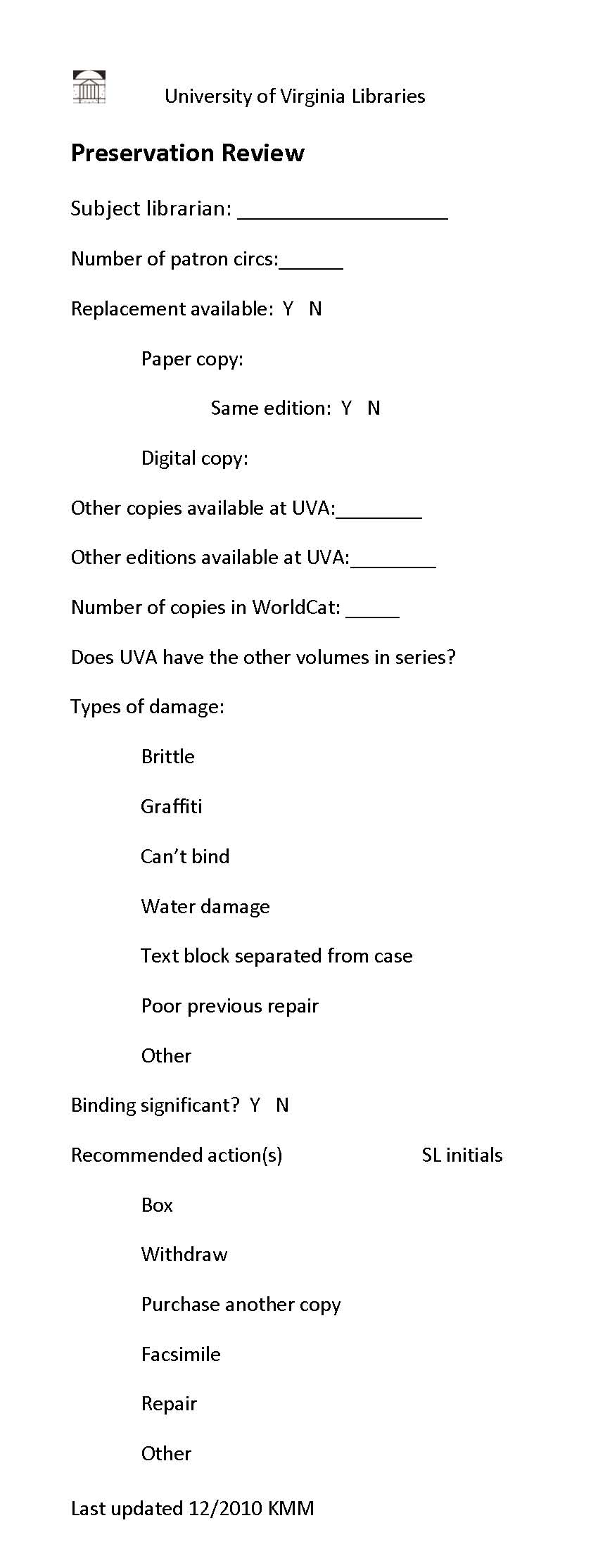
FIGURE 2. Books Stored in Trays in Newly Renovated Ivy Stacks Facility
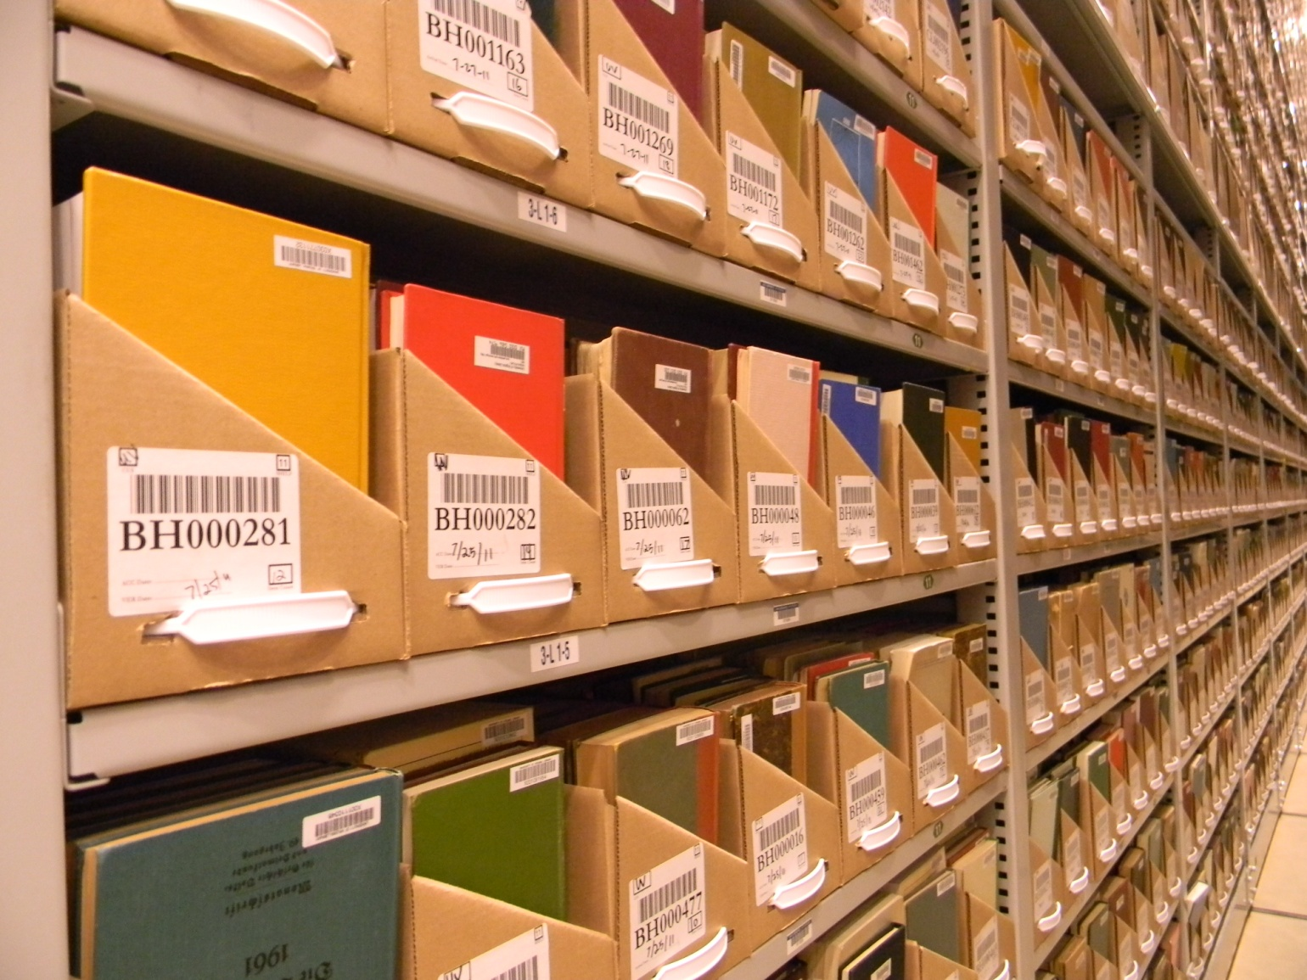

FIGURE 3. Ivy Retrofit Severely Damaged Workflow Flag
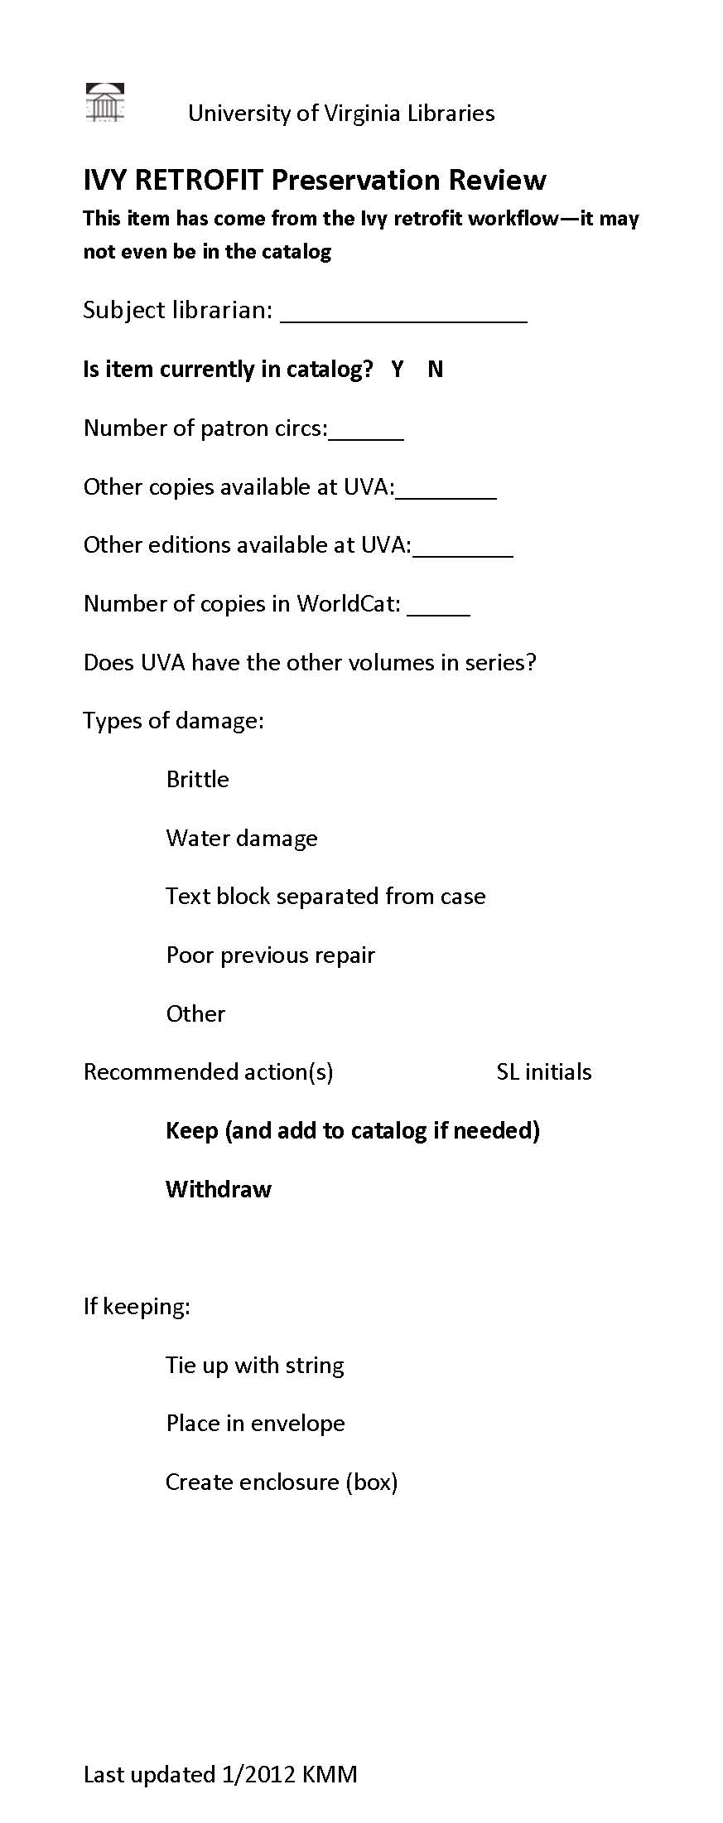
FIGURE 4. Number of Decisions Made Per Preservation Options

FIGURE 5. Percentage of Decisions by Subject Area/Location.

FIGURE 6. Comparison of Withdrawals for Ivy Retrofit Project vs. Regular Workflow

FIGURE 7. Percentage of institutions that include types of damage in workflow. Note: The “Other” category included missing/incomplete pages, biohazard contamination, heavy wear, theft, mold, insect and accidental damage, and the copyright status (since that affects the ability to create and make available digital copies.)

FIGURE 8. Percentage of institutions that gathered the following types of information. Other responses included the number of copies located within a geographic distance or among a consortium, curriculum demands, copyright status, costs of replacement/facsimile/repair

FIGURE 9. Percentage of institutions that make the following preservation decisions

FIGURE 10. Percentage of institutions that include various staff in decision-making

Figure 11. Number of institutions who spent varying percentages of FTE time on damaged materials workflow

Notes Edward Gaynor, “Unpublished History of the University of Virginia Library” (1999), email message to authors, November 28, 2011.
Albert and Shirley Small Special Collections Library. For more information, see http://www2.lib.virginia.edu/small/ .
We decided to focus exclusively on Google Books and the Internet Archive for two reasons: We believe that the infrastructure is in place to ensure free, long-term access to these digital files and they are two of the largest digital collections that fit the scope of our collections. We are currently exploring the possibility of searching Hathi Trust in addition to these two sources. The subject librarians were not interested in knowing if microfilm copies were available for replacement.
List of preferred vendors is available from authors upon request.
Survey Monkey is a free, online survey tool. For more information, see www.surveymonkey.com.
Jacob Nadal and Annie Petersen, “Scarce and Endangered Works: Using Network-level Holdings Data in Preservation Decision Making and Stewardship of the Printed Record (Draft), http://www.jacobnadal.com/wp-content/uploads/2011/05/Scarce%20and%20Endangered%20Works%28v19Sept2011%29.pdf.

